Problem Statement
A clothing retailer holds 5,000 customer reviews with mixed data types: Boolean recommendation flags, ordinal text ratings (“Loved it” … “Hated it”), free-text department and division names, and date strings. These features cannot be fed directly into most machine-learning models. The data-science task is to transform the categorical, ordinal, and temporal columns into clean numeric representations and then scale them so that downstream models (recommendation prediction, rating regression, etc.) receive a consistent, model-ready feature matrix.

Solution Strategy
- Binary-encode recommended (True → 1, False → 0) via dictionary map (or .astype(int)).
- Ordinal-encode rating with an ordered dictionary (Loved it = 5 … Hated it = 1).
- One-hot encode department_name (and optionally division_name) with pd.get_dummies; join columns back.
- Convert review_date to datetime and derive year / month / day-of-week features.
- Select the resulting numeric columns, set clothing_id as index, apply StandardScaler (and compare with MinMaxScaler).
- Extend with age bins, simulation of inverted scales / subset scaling, and visual diagnostics.

Solution
Core transformation results (5,000 reviews):
- recommended: 4,166 True → 1; 834 False → 0
- rating ordinal: Loved it 2,798 (5), Liked it 1,141 (4), Was okay 564 (3), Not great 304 (2), Hated it 193 (1)
- department one-hot: 6 binary columns (Tops 43.9 %, Dresses 26.4 %, Bottoms 17.0 %, …); 4 NaNs become all-zero rows
- review_date successfully converted to datetime64; year/month/dow extracted
- After StandardScaler: age mean ≈ 0, std ≈ 1; binary flags and rating likewise centered and unit-scaled
Figure 1 – Age & Rating distributions before vs after StandardScaler
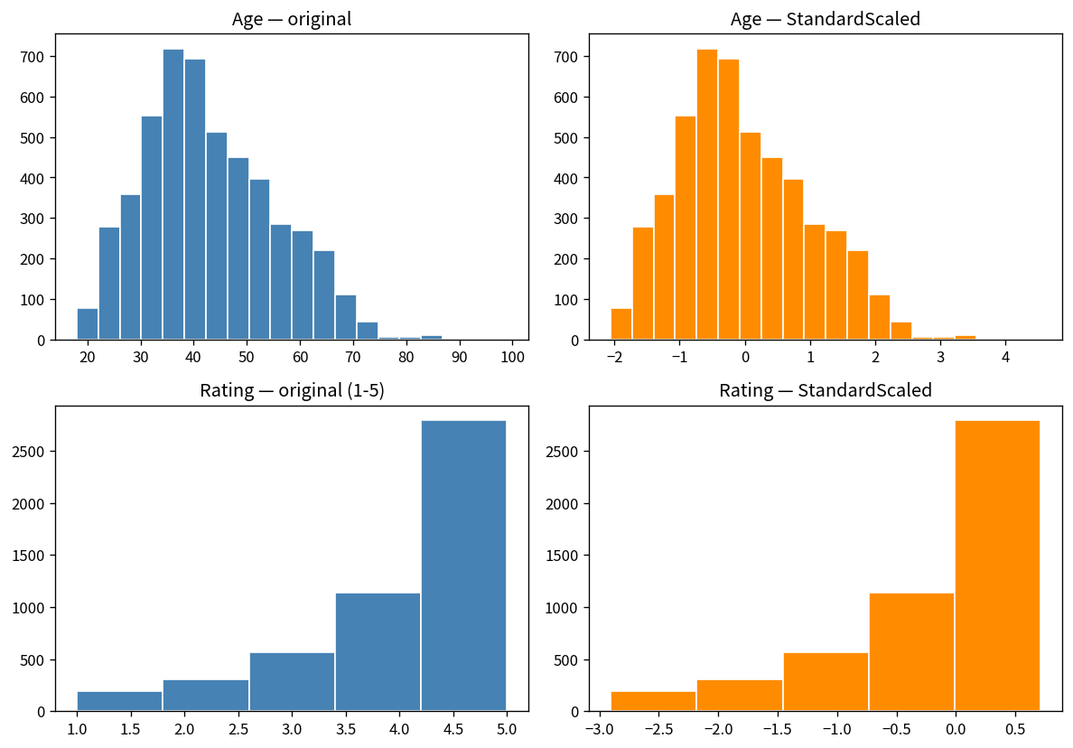
Figure 2 – Simulation: original age vs StandardScaler vs MinMaxScaler
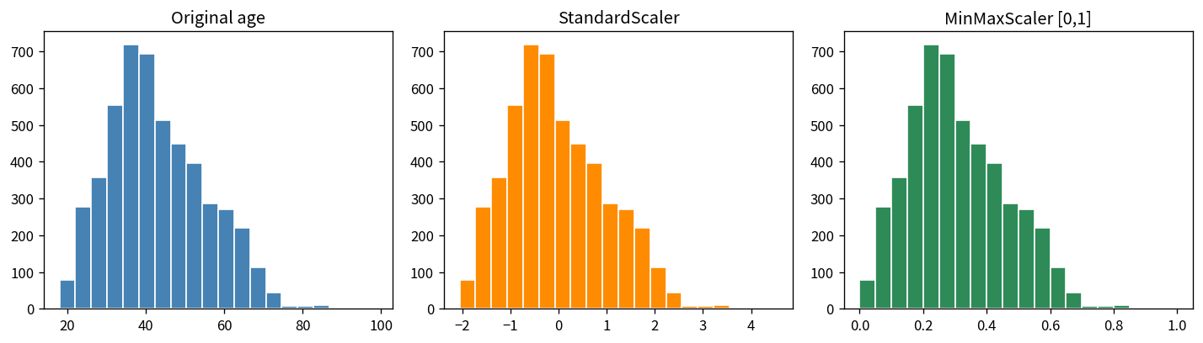

Key Takeaways
- Always inspect value_counts and dtypes before and after each transform; the 4 missing department values are otherwise silent.
- Boolean → integer and ordered text → integers are the simplest high-impact steps for model readiness.
- One-hot encoding expands cardinality; consider drop_first or target encoding for high-cardinality categories in larger pipelines.
- StandardScaler (zero mean, unit variance) is the default choice when features have disparate ranges; MinMaxScaler is useful when a [0,1] bound is required.
- Derived datetime parts and age bins add temporal and demographic signal without any external data.
- The resulting numeric matrix is ready for classification of recommendation status or regression on the ordinal rating.

